**Memo**

To: Professor Pisano

From: Muayad Al Riyami, Ben Gross, Andrew Chen , Fatima Dantsoho, Seunghak Shin

Team: 17 (Future of Heat)

Date: 11/22/2020

Subject: Prototype Test Report

1. **Setup and Testing Procedure**

The team is testing two parts of the project: the Arduino’s circuit and the web app’s user interface.

**A. Arduino:**

The Arduino circuit will be set up according to the following schematic, to test the accuracy of the voltage reading and power calculation.

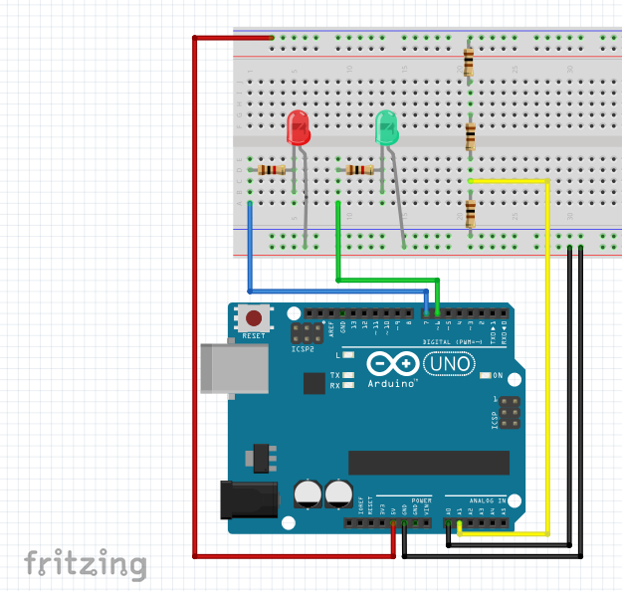

The Arduino code will be tested on two things: If it lights the correct colored LED depending on the user input (green when the input is electric heating and red when the input is natural gas heating), and if it measures the correct voltage across the resistor and calculates the corresponding power value. The test will be repeated three times with different resistor values each time. Once with 100 ohms, once with 200 ohms, and once with 300 ohms.

**B. Web application:**

The web app will be tested on the functionality of a few things. First, check that all different pages are accessible from the main page and that maneuvering from every page back to the home page is possible. Second, all user inputs are controllable with working range sliders that store values correctly. The outputs are automatically populated based on the user inputs. Third, the interactive map highlights the part that the mouse is hovering over.

Note:

* For testing purposes, a picture of the solar system is replacing the actual map as the project map is not ready yet.
* At this time, the output calculation formulas are not accurate. We are still working on it.
* The arduino and web application will be hosted on firebase.

**2.0 Results**

**A. Arduino**

The green/red LEDs worked as follows:

|  |  |  |
| --- | --- | --- |
| Input(serial monitor) | Output | |
| Green | Red |
| ‘N’ for natural gas | Off | On |
| ‘E’ for electricity | On | Off |

The Arduino circuit results were as follows:

|  |  |  |  |  |  |  |  |
| --- | --- | --- | --- | --- | --- | --- | --- |
| Load Resistance | VTheoretical | VActual | PTheoretical | PActual | V % Error | P % Error | LEDs Correct? |
| 100 Ω | V | 1.6446 V | W | 0.02778 W | 1.32% | 2.8% | Yes |
| 200 Ω | V | 3.328 V | W | 0.05556 W | 0.154% | 0.46% | Yes |
| 300 Ω | 5.0 V | 4.9922 V | W | 0.08306 W | 0.156% | 0.328% | Yes |

**B. Web application:**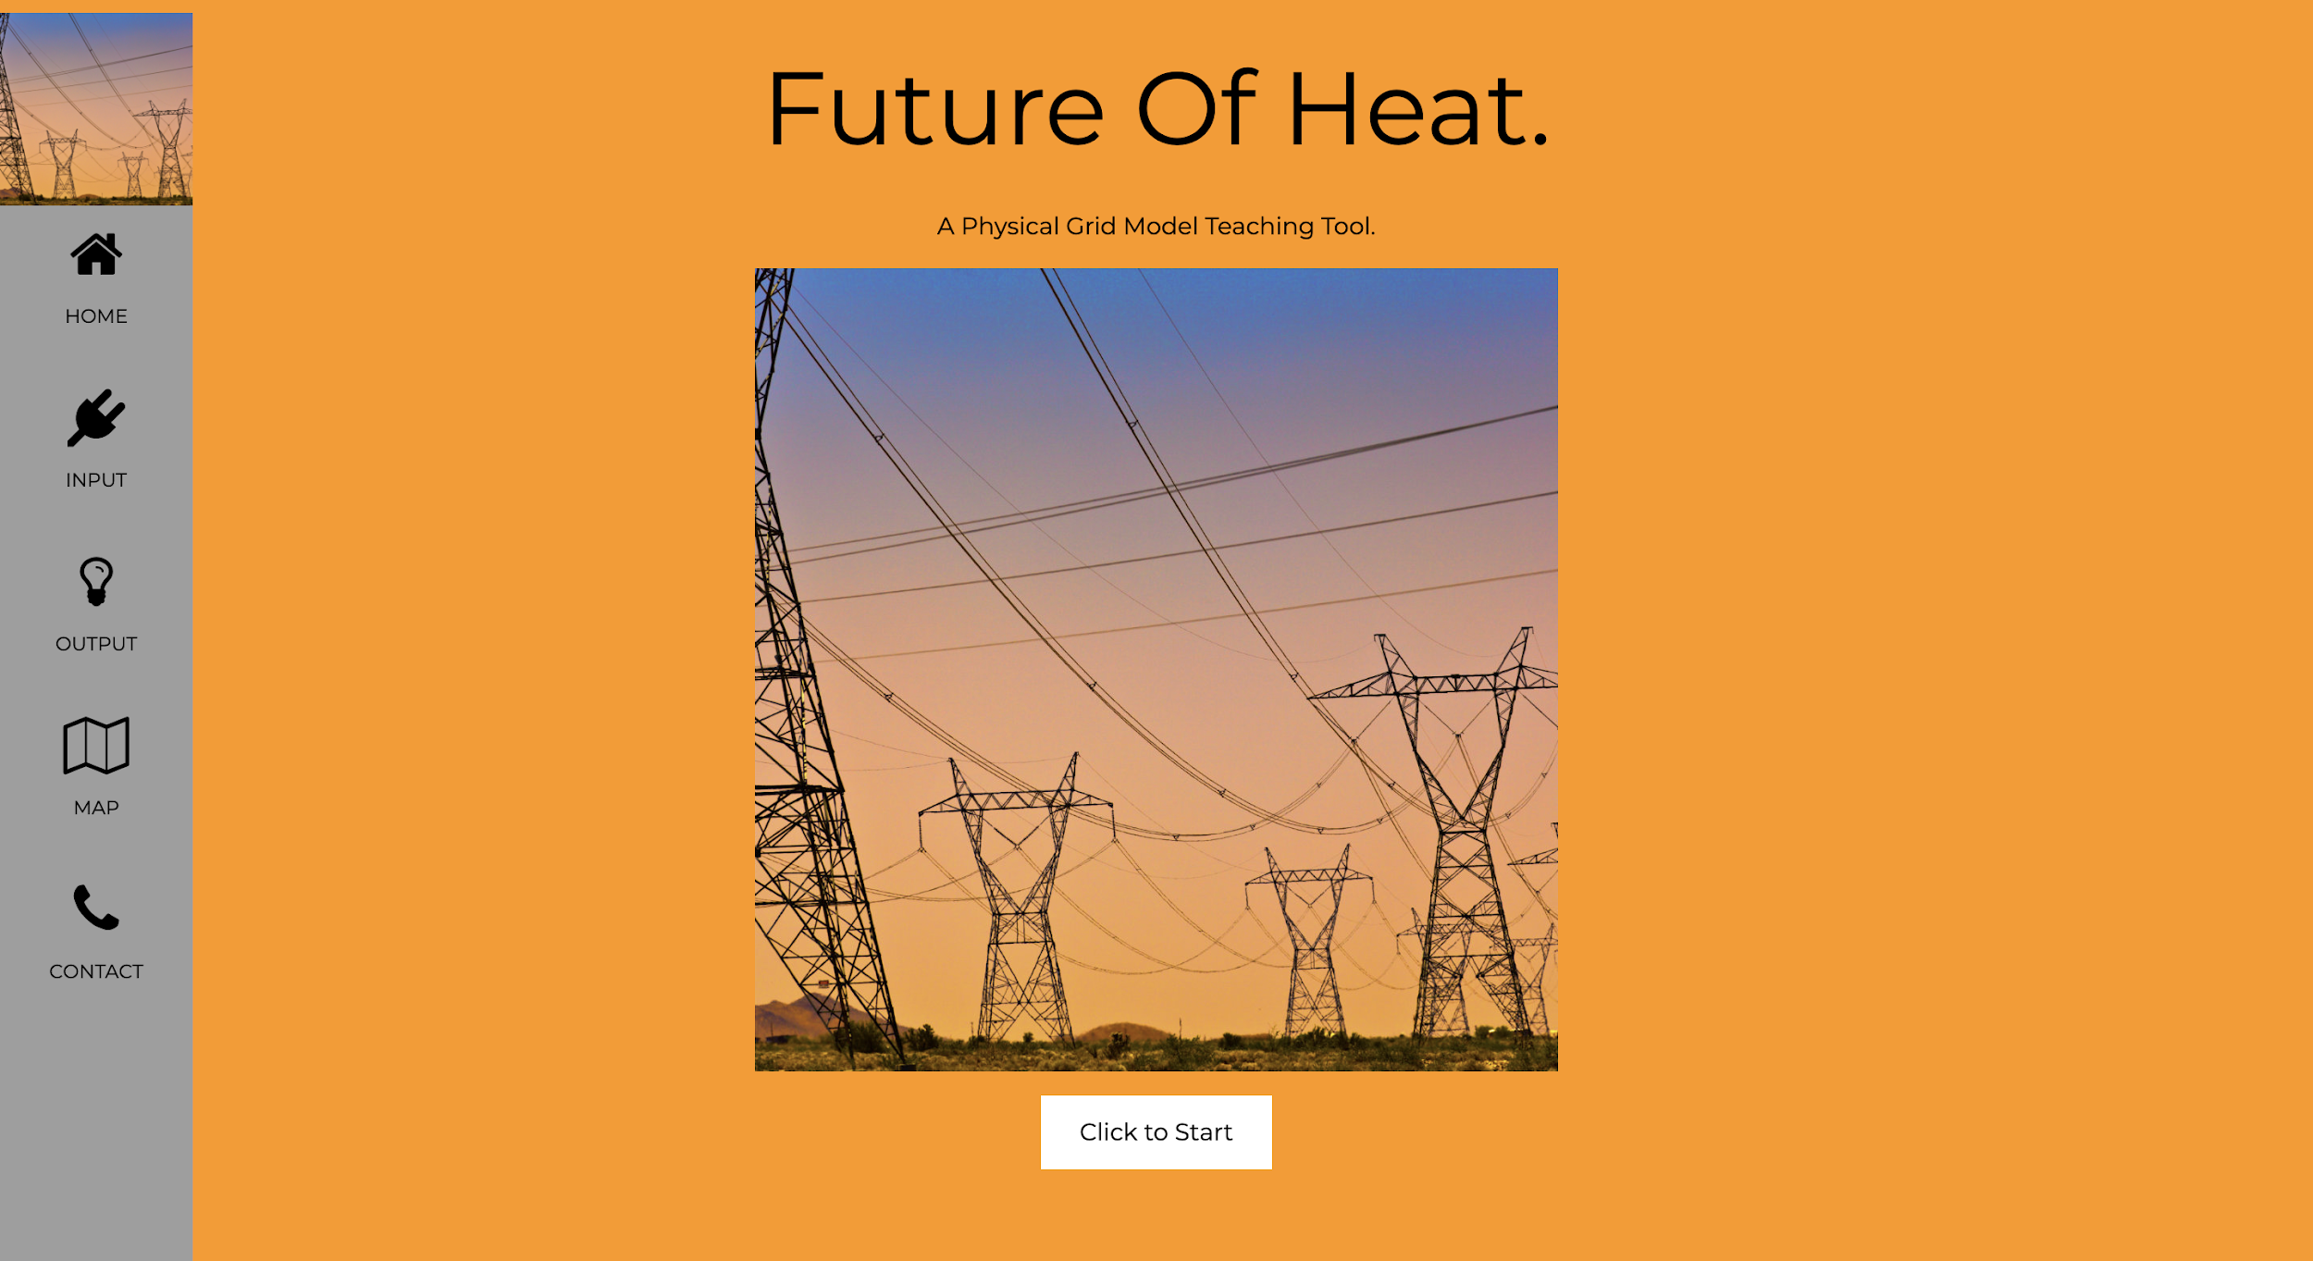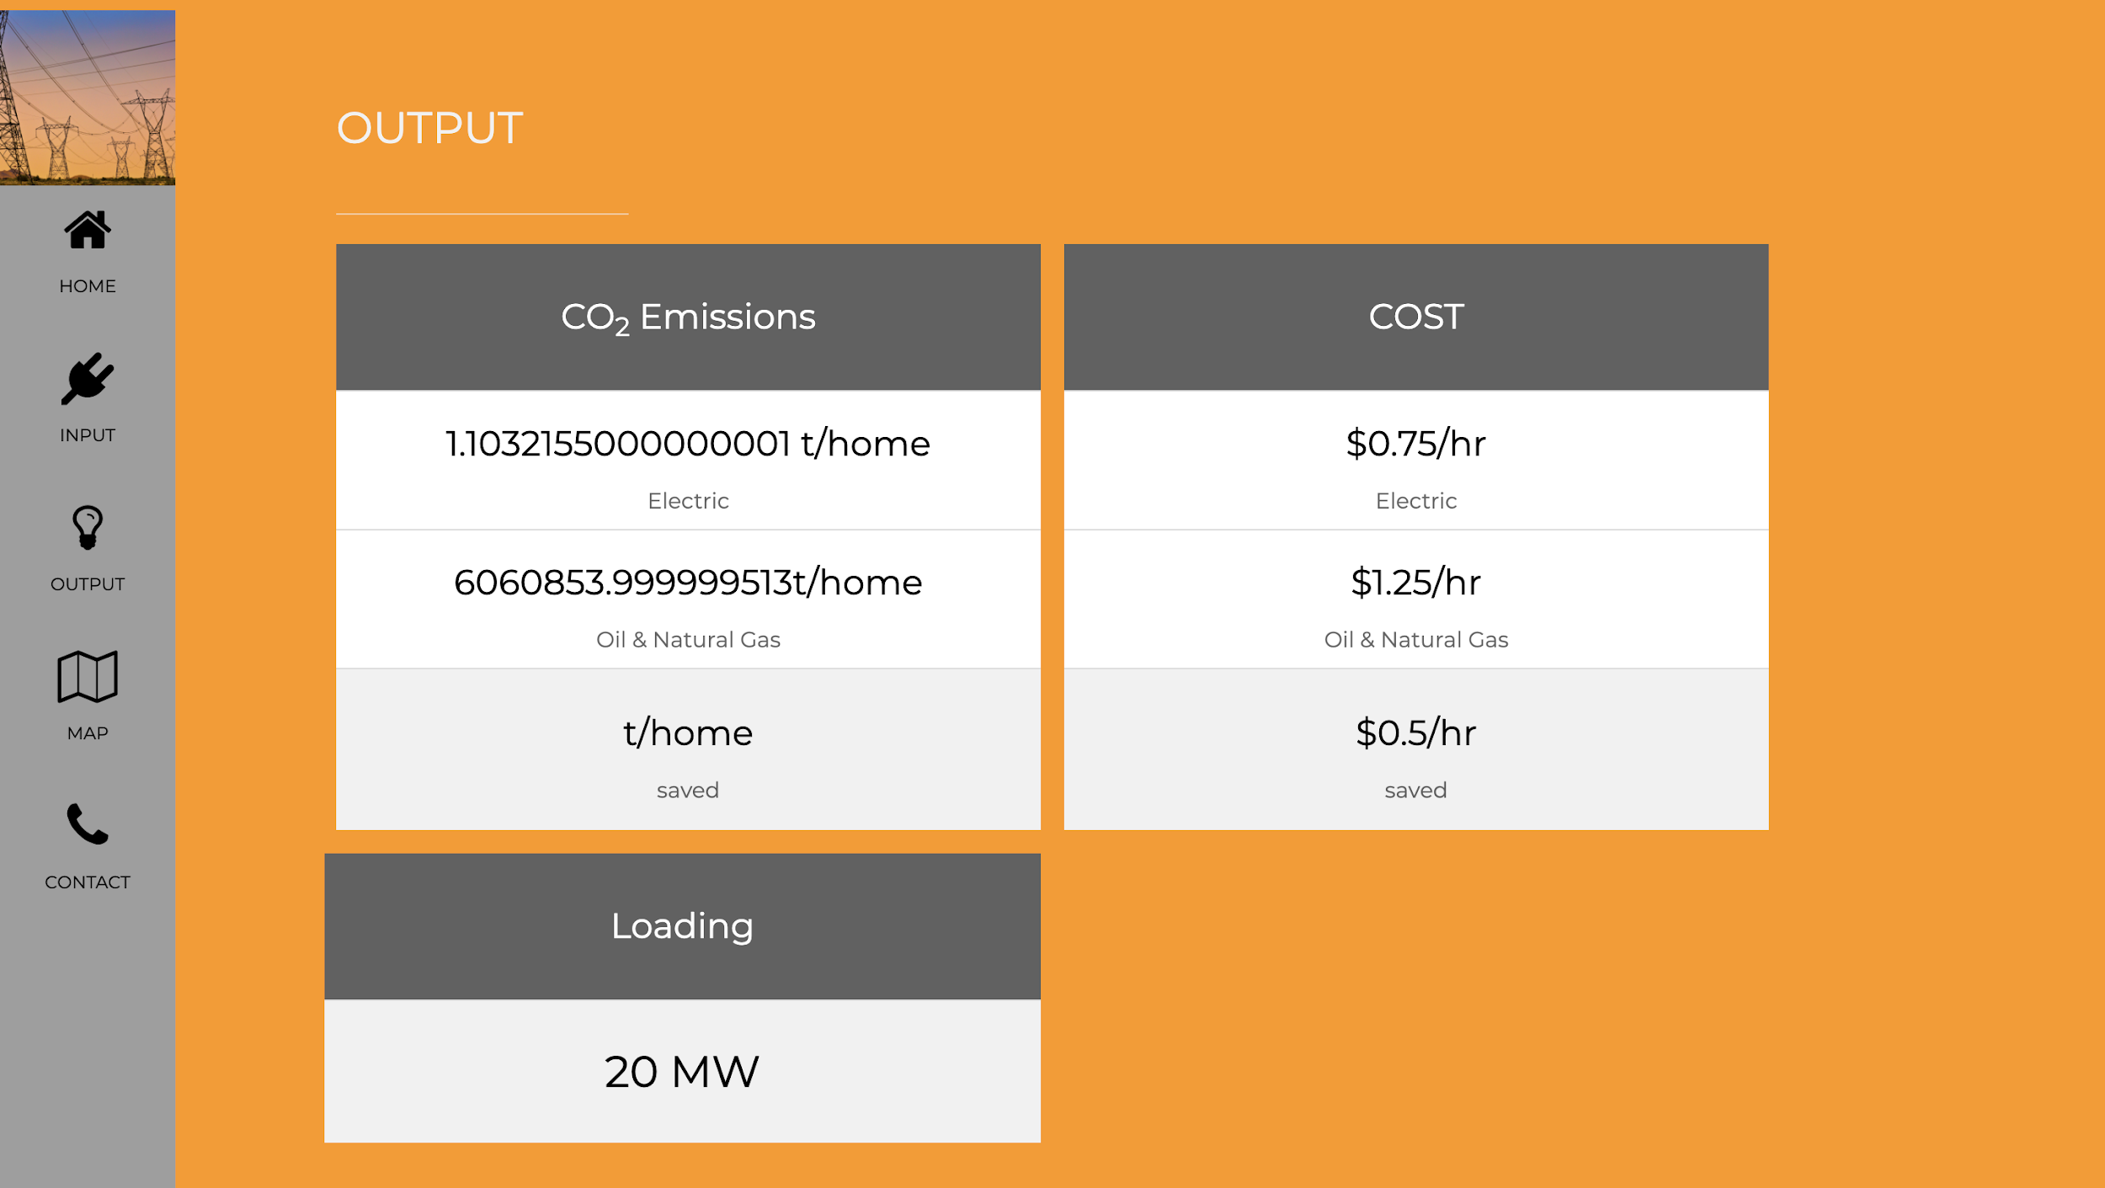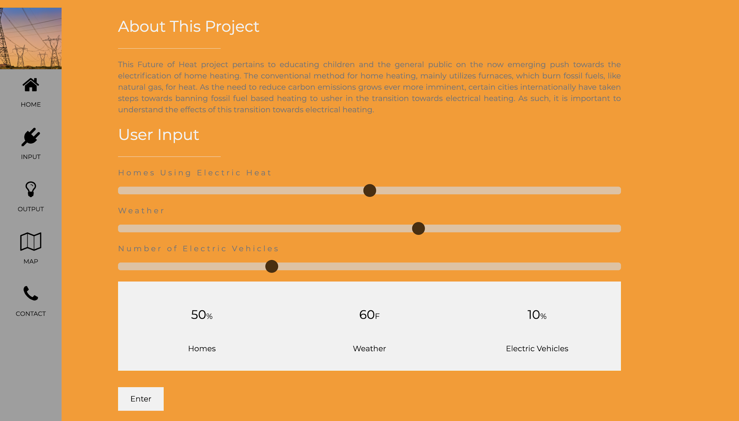

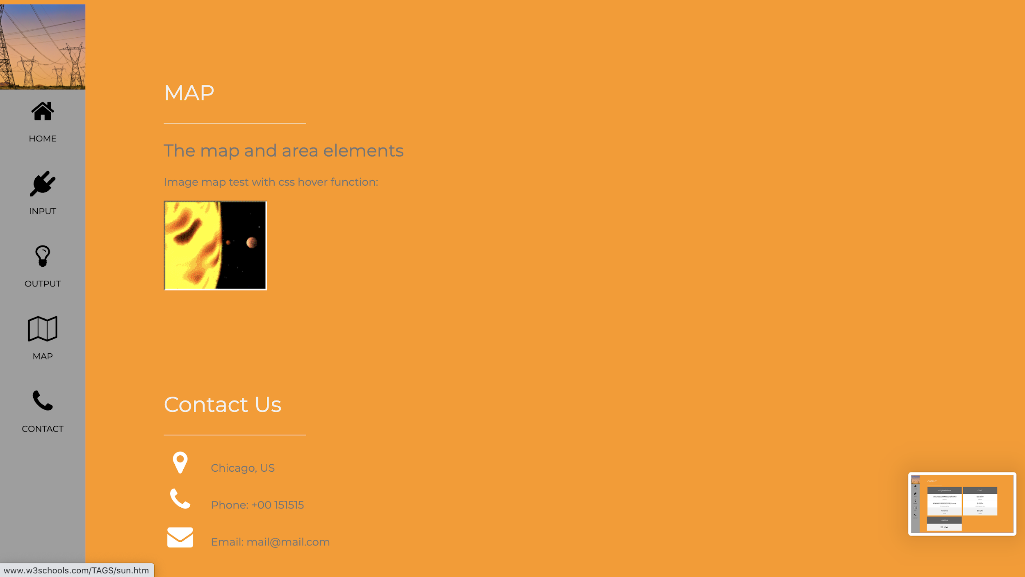

**3.0 Conclusion**

All in all, the testing was successful. We did not encounter any problems and the project components performed as expected. The Arduino lit up the correct LED that corresponded to the user input. And it measured relatively accurate voltage values and calculated the power, the percent error came mainly from the 0.00488 V resolution limit imposed by the 10 bit size when converting from analog to digital. The web application had smooth transitions between pages, and registered input values correctly using range sliders. The mock-up map worked as intended by highlighting the components when the mouse hovered over them. However, we need to reduce the precision of the output numbers to about 3-4 decimal places.